

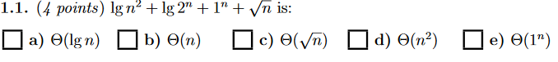

b) because $lg2^{n} has the highest growth$

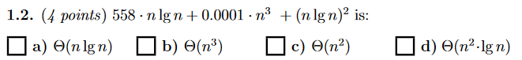

b)

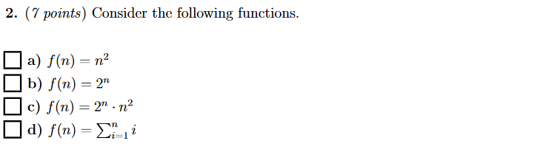



1. d) because d is the same as $lg⁡(n^{2}+n)$ which is the same as $lg⁡(n^{2})$, which is = to $2*\lg\left(n\right),$ which is the same as $T(lgn)$ because we do not care about constants when it comes to growth.

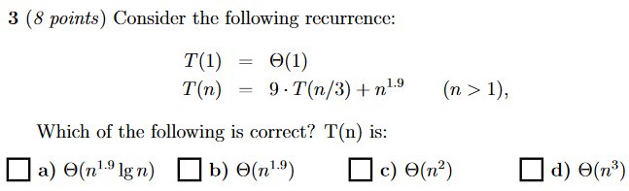

1. see lesson 4 notes

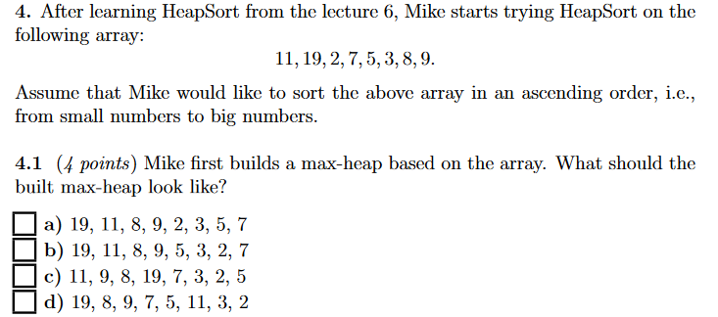

b)

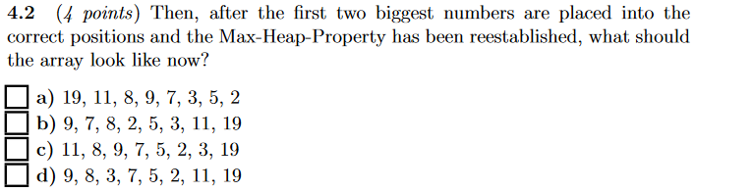

b)

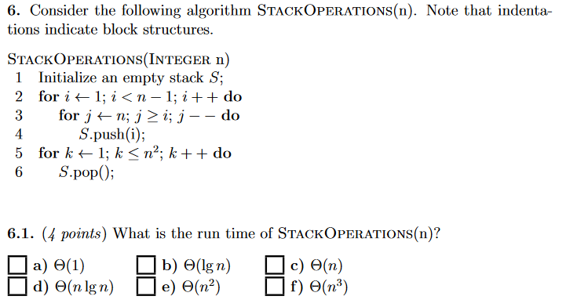

e)

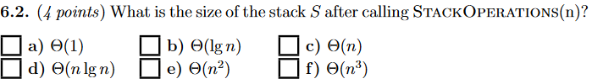

a)

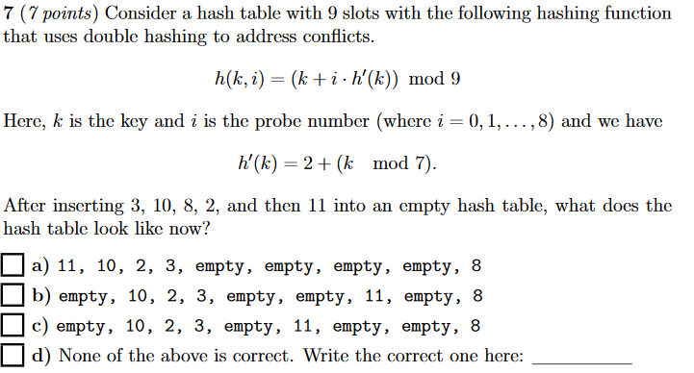

c)

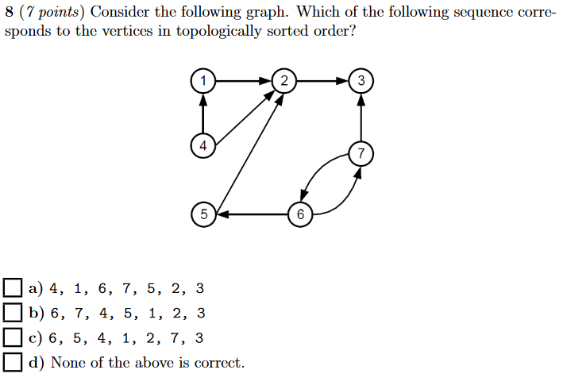

d – because cycle between 6 and 7

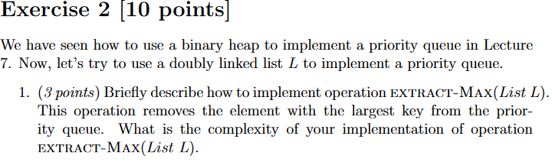

Since list L is a priority queue, the greatest value is always at the top. This means that with extract-max we just need to get the first element in L.

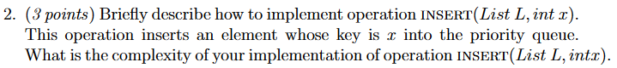

Go through the entire list to find a set of 2 numbers where one is great and another is lesser than x. Then place x between those two numbers. Worst-case runtime is n.

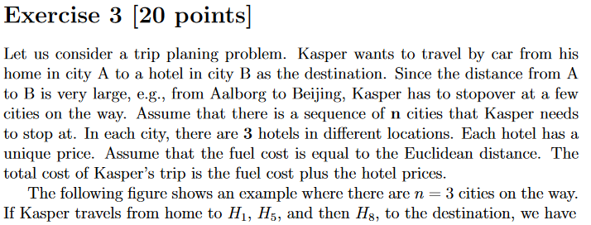

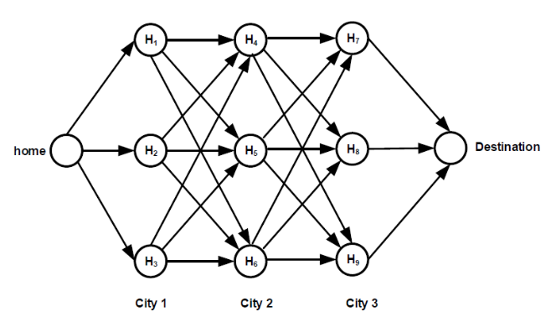

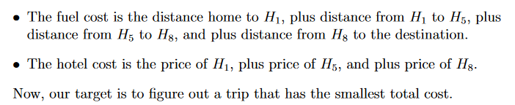

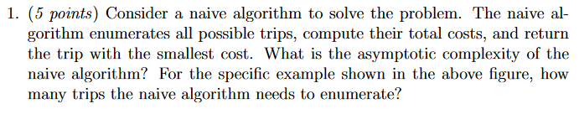

$$3^{n}, 3^{3} for this specific example$$

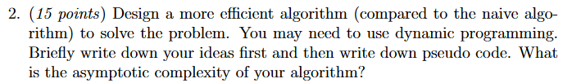

Use Dijkstra’s algorithm, take into account the travel cost to a hotel plus the hotel cost.

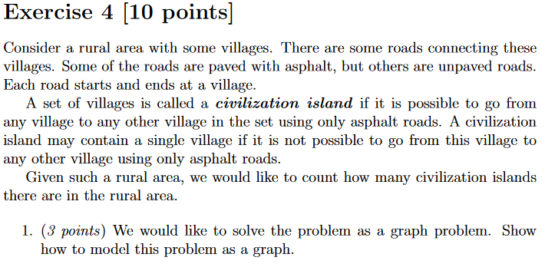

Mark villages as vertices, use asphalt roads as edges.



Depth-first search boi.